## 



# **Project Name: Weather App Using React**

**Name: Tisha Chawla**

**Registration no. 20BCE0284**

**Github repository:** [**https://github.com/tishachawla-jg/tishachawla-js.weather**](https://github.com/tishachawla-jg/tishachawla-js.weather)

**Google drive link:** [**https://drive.google.com/drive/folders/1OqQf1zyNr_2tB_qEH6QKyWJcP16BmCzh?usp=sharing**](https://drive.google.com/drive/folders/1OqQf1zyNr_2tB_qEH6QKyWJcP16BmCzh?usp=sharing)

**1. What is your role?**

I made this project by myself to find out the weather of any place in the world using ReactJs.

**2. What you learned while building the project ?**

* I learnt the basics of ReactJs and gained deep insight into its declarative,component based and reusable nature.
* I learnt how to integrate API in a website.For this project particularly ,I used a weather API from https://home.openweathermap.org/.

**3.Did you take any courses like coursera, udemy...etc ,,while working for your project .**

* Firstly,I read about ReactJs and how to create a react app .
* I worked on the tic-tac-toe game in the reactjs official site to learn how it works.
* I saw some videos to learn about the components in ReactJs.
* I referred to this https://www.youtube.com/watch?v=GuA0_Z1llYU video to make my project.

**4. Mention the libraries that you have installed for the project.**

ReactJs

**5.Also explain the workflow of the project?**

1) Created the React app called weather-react then deleted some files from src that were not useful for my project.

2)Added the search box and the background picture.

3)Styled the template using css.

4)Integrated a weather API .

5)Connected the weather API to the search bar and displayed the result at the bottom.

6)If the weather is cold then the template will be of a mountain while for sunny weather the template will be of a river(Using ternary operators) .

**6. Screen shots:**



**HOT WEATHER(>16 Celsius)**

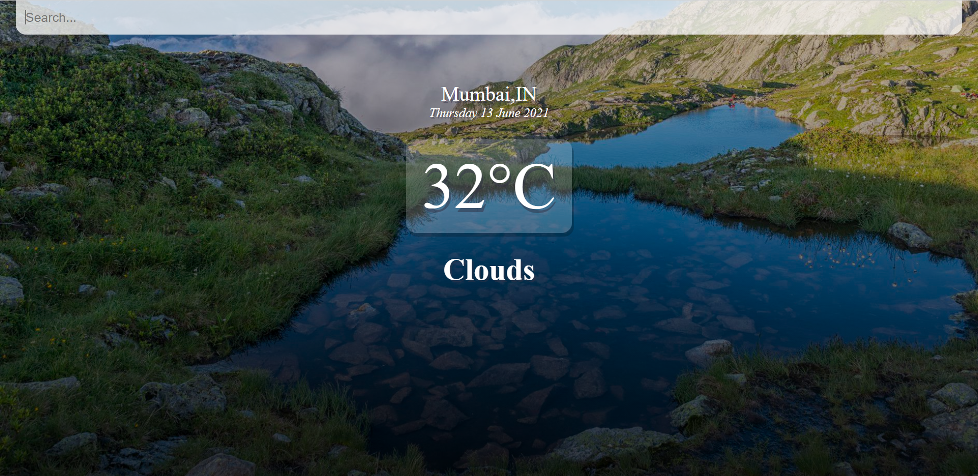

**COLD WEATHER(<16 Celsius)**

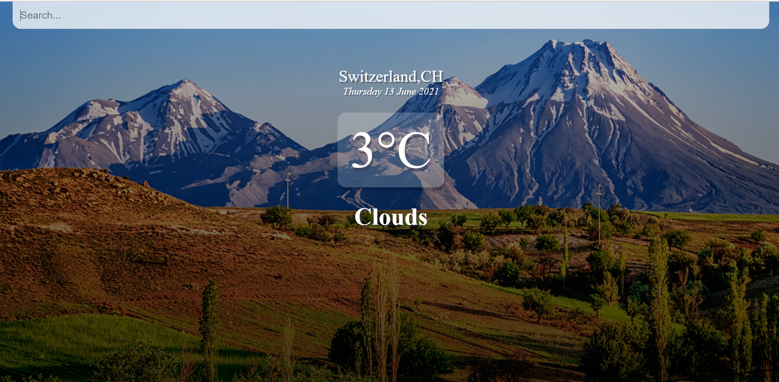

**RESPONSIVE**

